BUKTI KERJA - SCREENSHOT & OUTPUT CODING

Prediksi Curah Hujan Harian di India Menggunakan Long Short-Term Memory (LSTM): Pendekatan Multi-Domain untuk Mitigasi Bencana, Perencanaan Pertanian, dan Manajemen Sumber Daya Air

1. SCREENSHOT NOTEBOOK & ENVIRONMENT

1.1 Jupyter Notebook - Main Project
File:project-deep-learning-lstm-rainfall-in-india.ipynb
Screenshot 1: Import Libraries & Setup
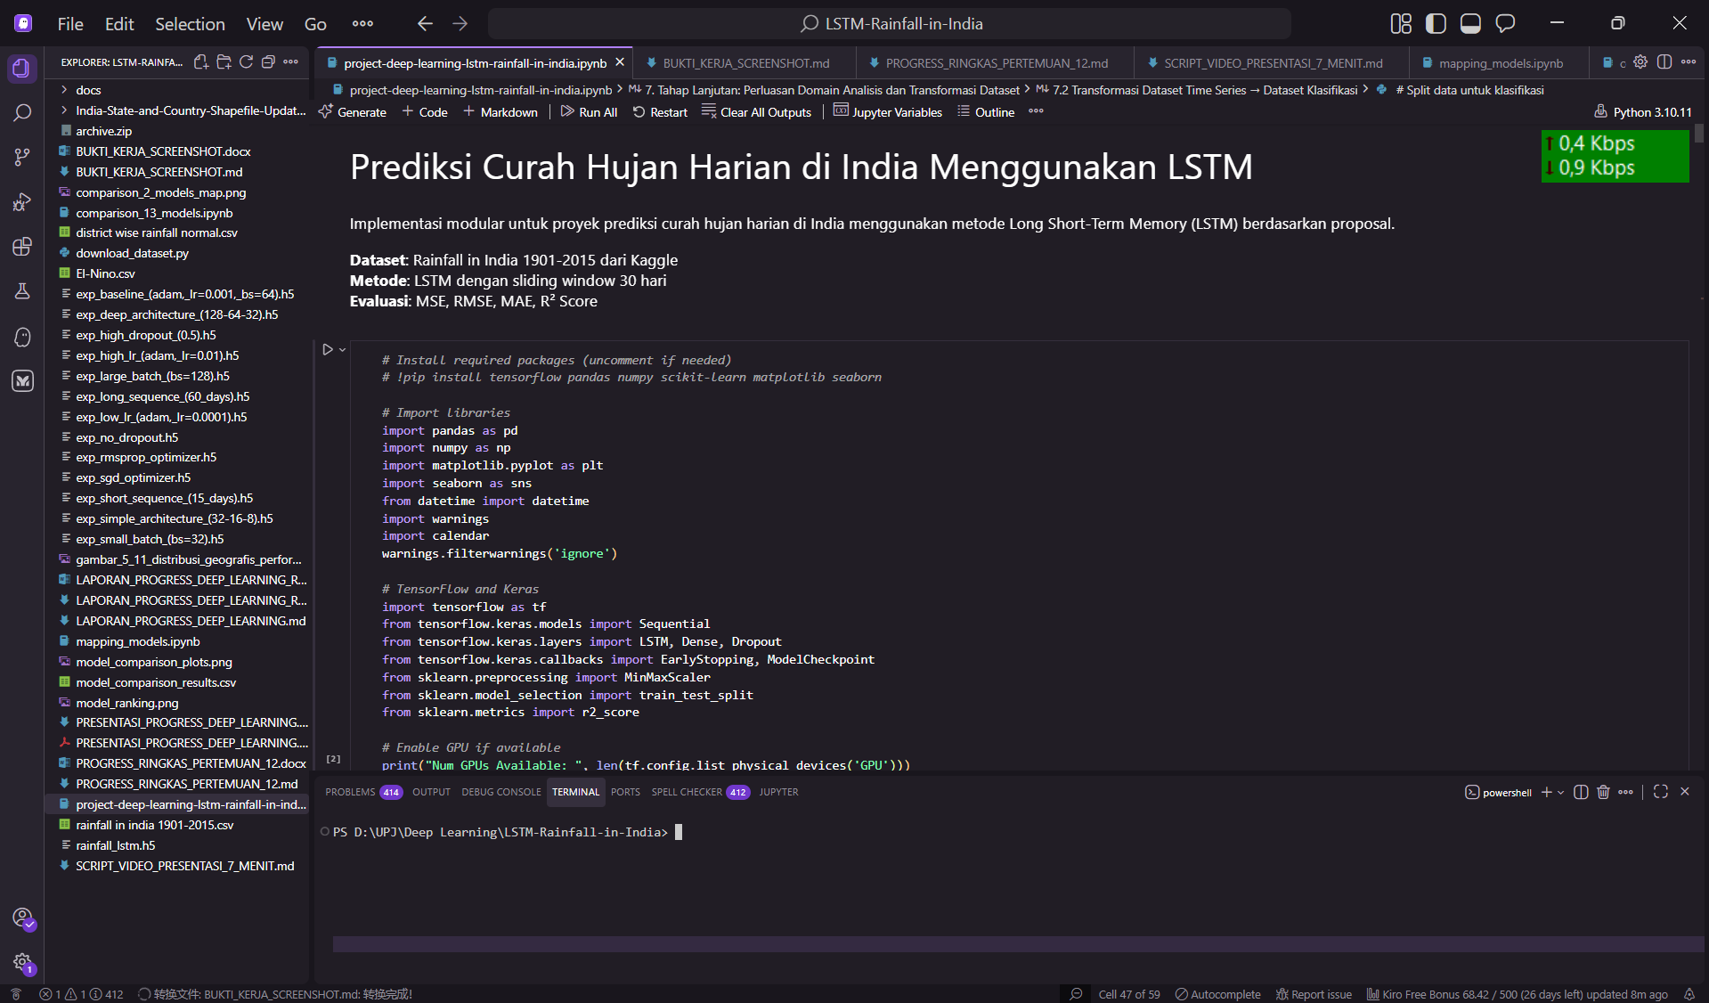
Screenshot 2: Data Loading & Preprocessing
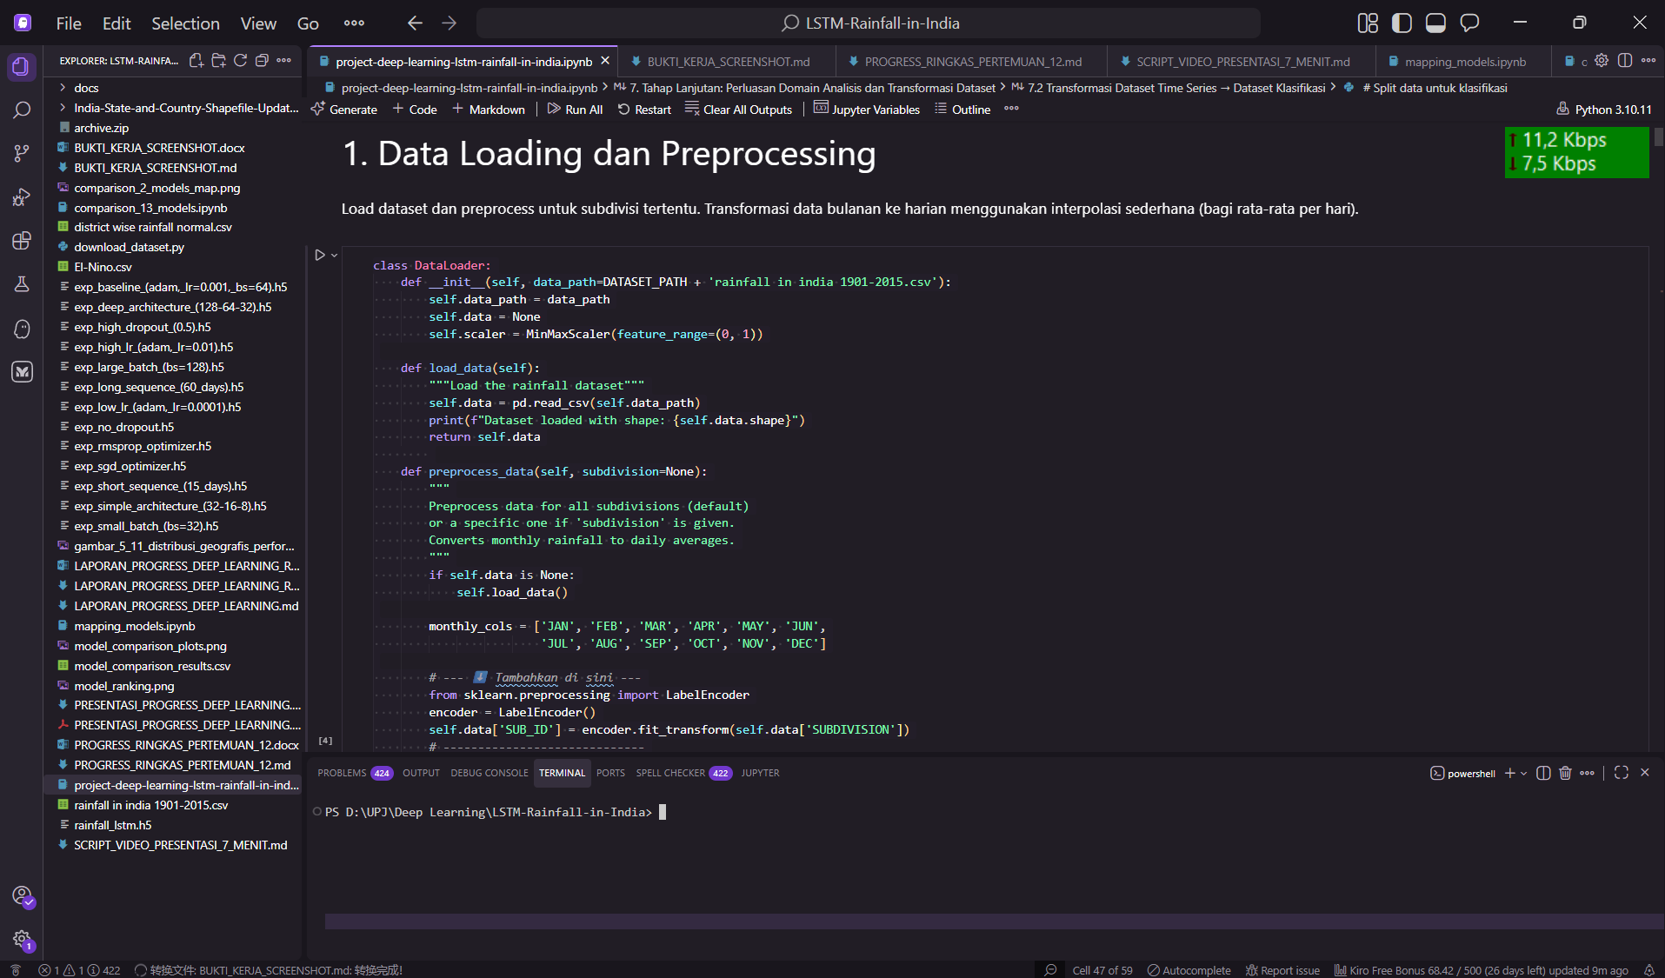

2. ARSITEKTUR MODEL & TRAINING

2.1 Model Architecture
Screenshot 4: LSTM Model Summary
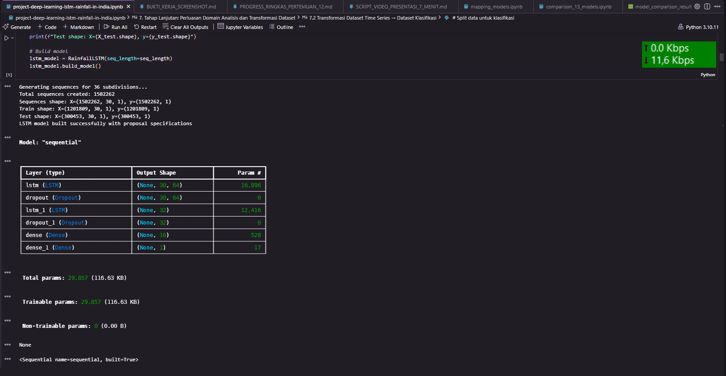

2.2 Training Process
Screenshot 5: Training Progress

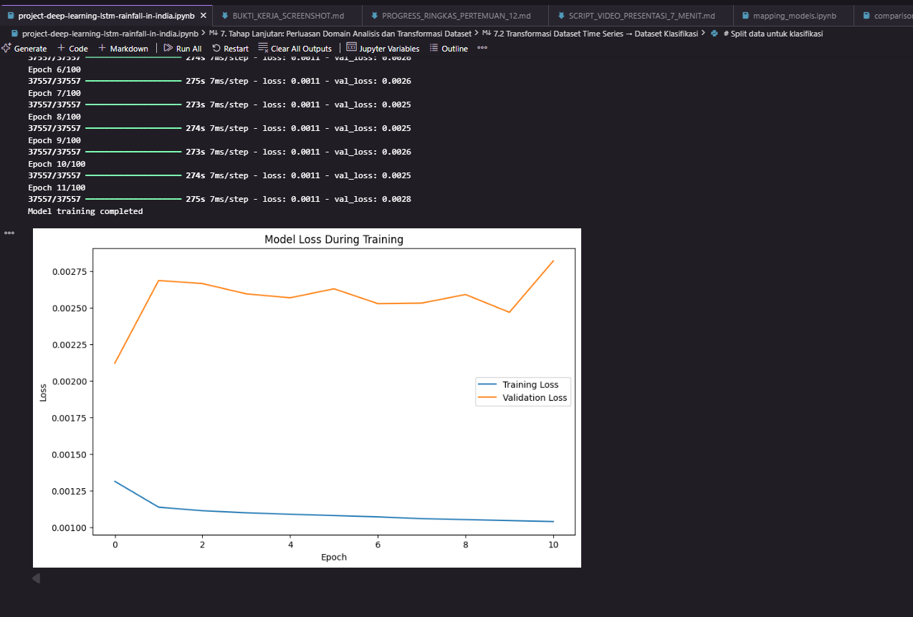

3. GRAFIK HASIL TRAINING

3.1 Training & Validation Loss
Grafik 1: Loss Curves
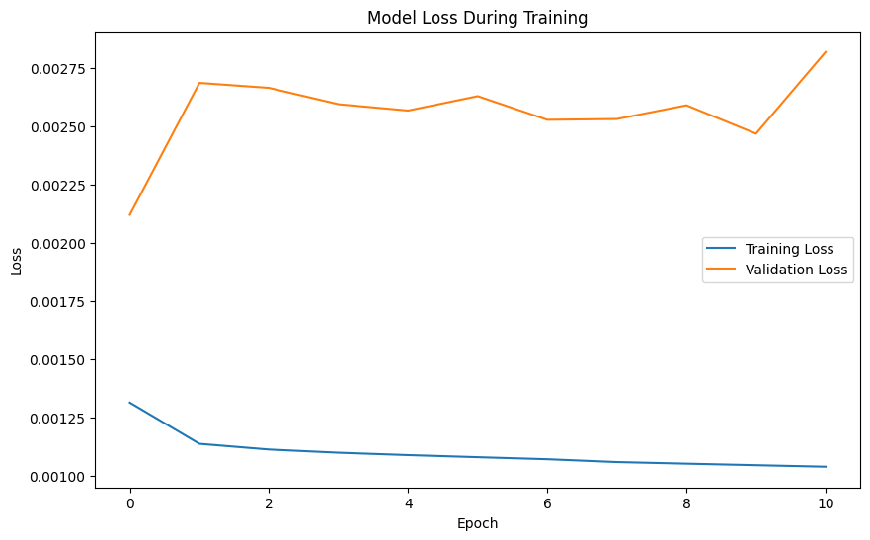

3.2 Prediction Results
Grafik 2: Predicted vs Actual (Time Series)
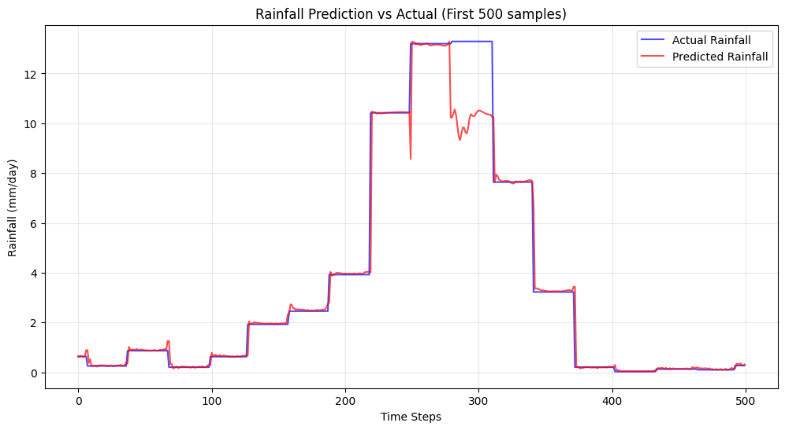
Grafik 3: Scatter Plot (Predicted vs Actual)
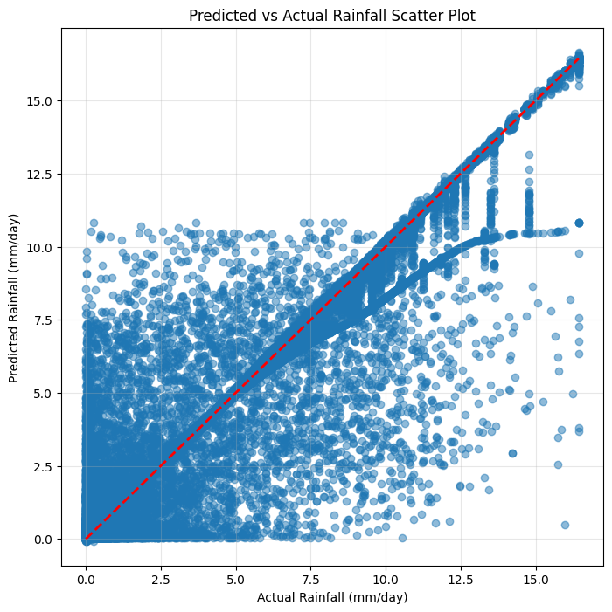

4. EKSPERIMEN 13 MODEL

4.1 Comparison Results
Model Comparison Table
Peringkat | Model | RMSE (mm) | R² Score
1 | No Dropout | 0.5022 | 0.9746
2 | Low Learning Rate (0.0001) | 0.5292 | 0.9718
3 | High Learning Rate (0.01) | 0.6306 | 0.9599
4 | High Batch Size(64) | 0.6330 | 0.9596
5 | Simple Architecture | 0.6480 | 0.9577
Grafik 4: Bar Chart Comparison (RMSE)
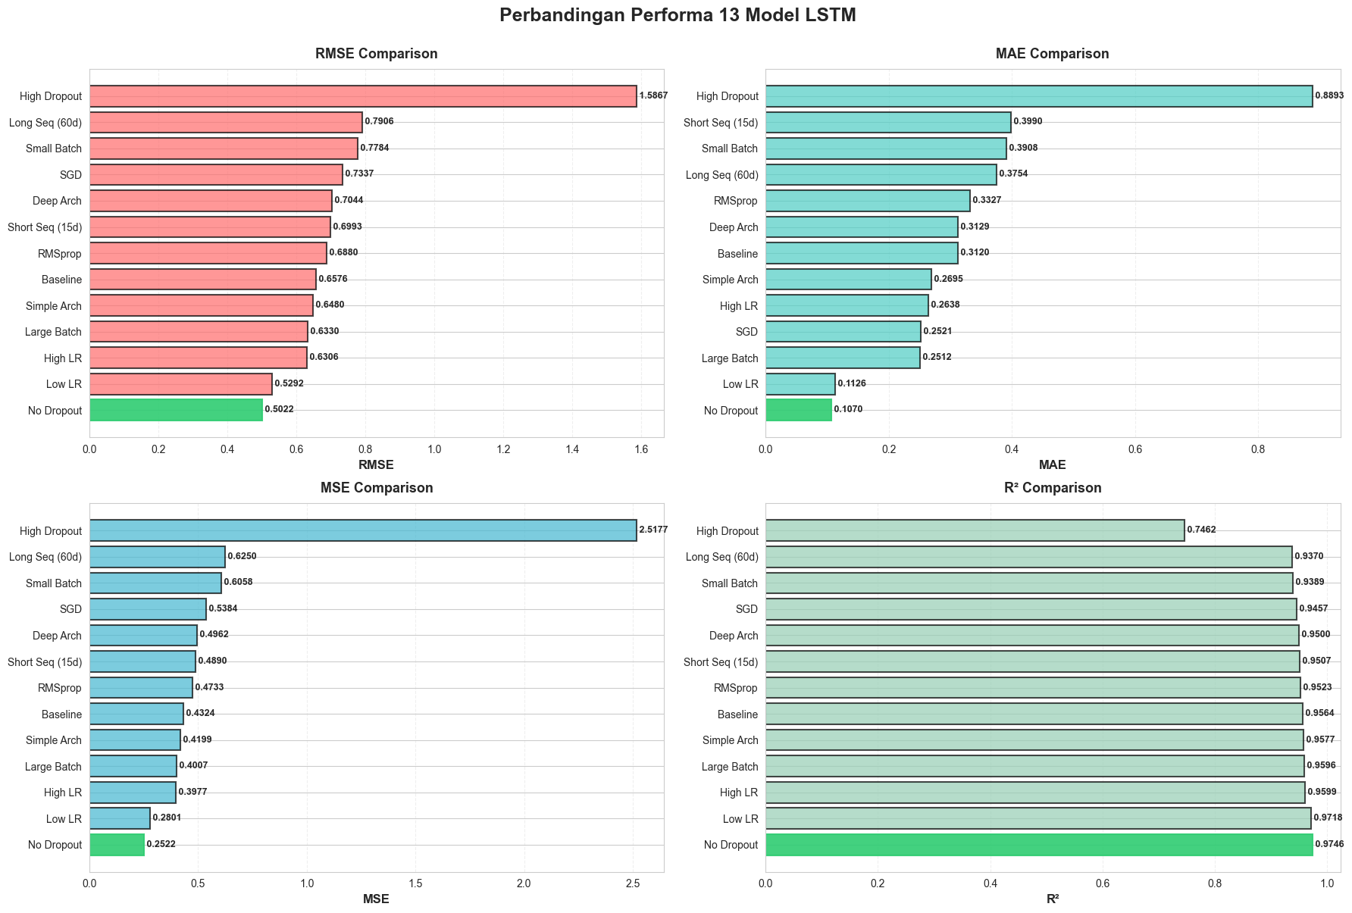

5. ANALISIS RESIDUAL

5.1 Residual Distribution
Grafik 5: Histogram Residuals
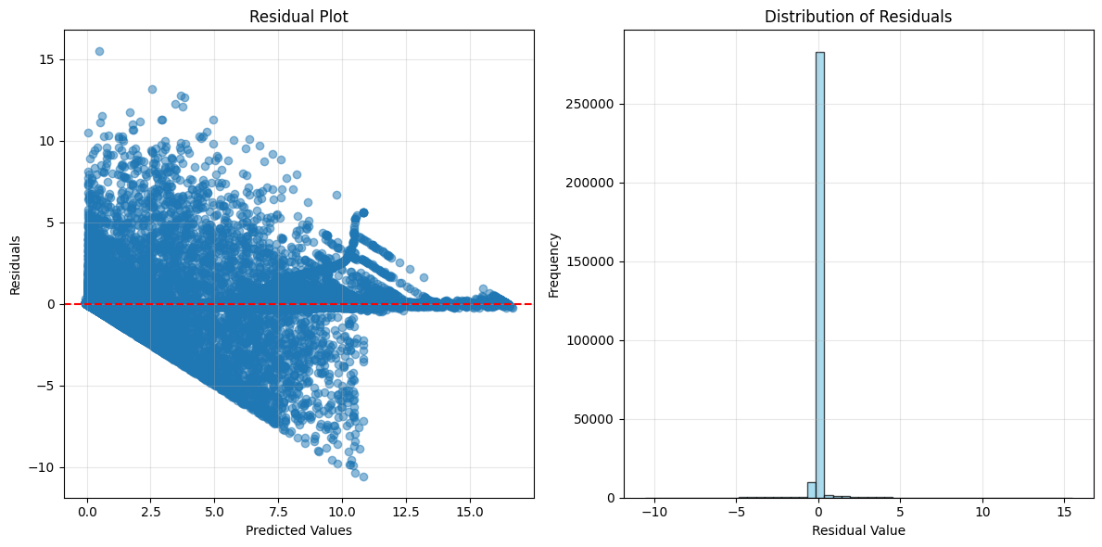

Grafik 6: Q-Q Plot
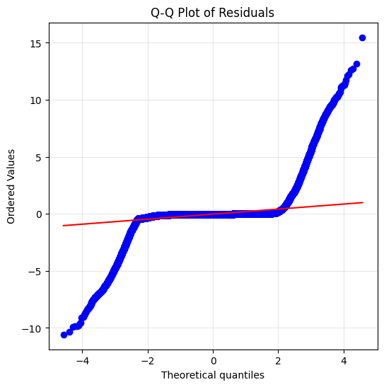

5.2 Autocorrelation Analysis
Grafik 7: ACF Plot
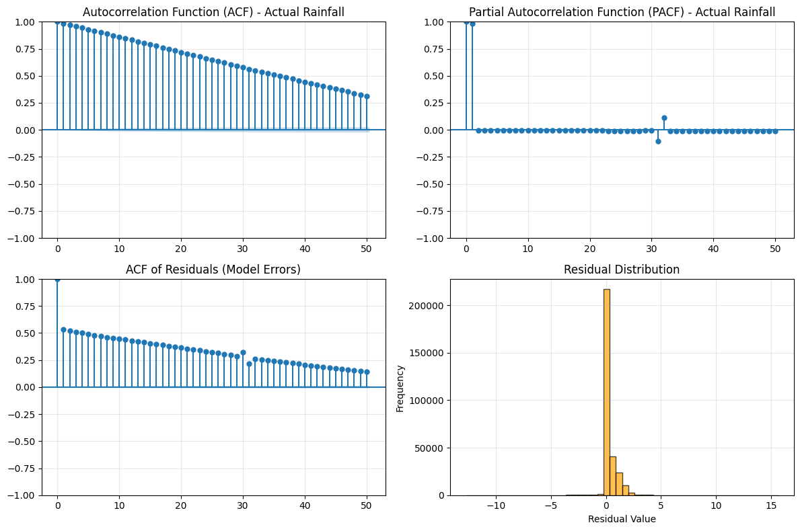

6. VISUALISASI DATASET

6.1 Data Distribution
Grafik 8: Distribusi Curah Hujan Tahunan
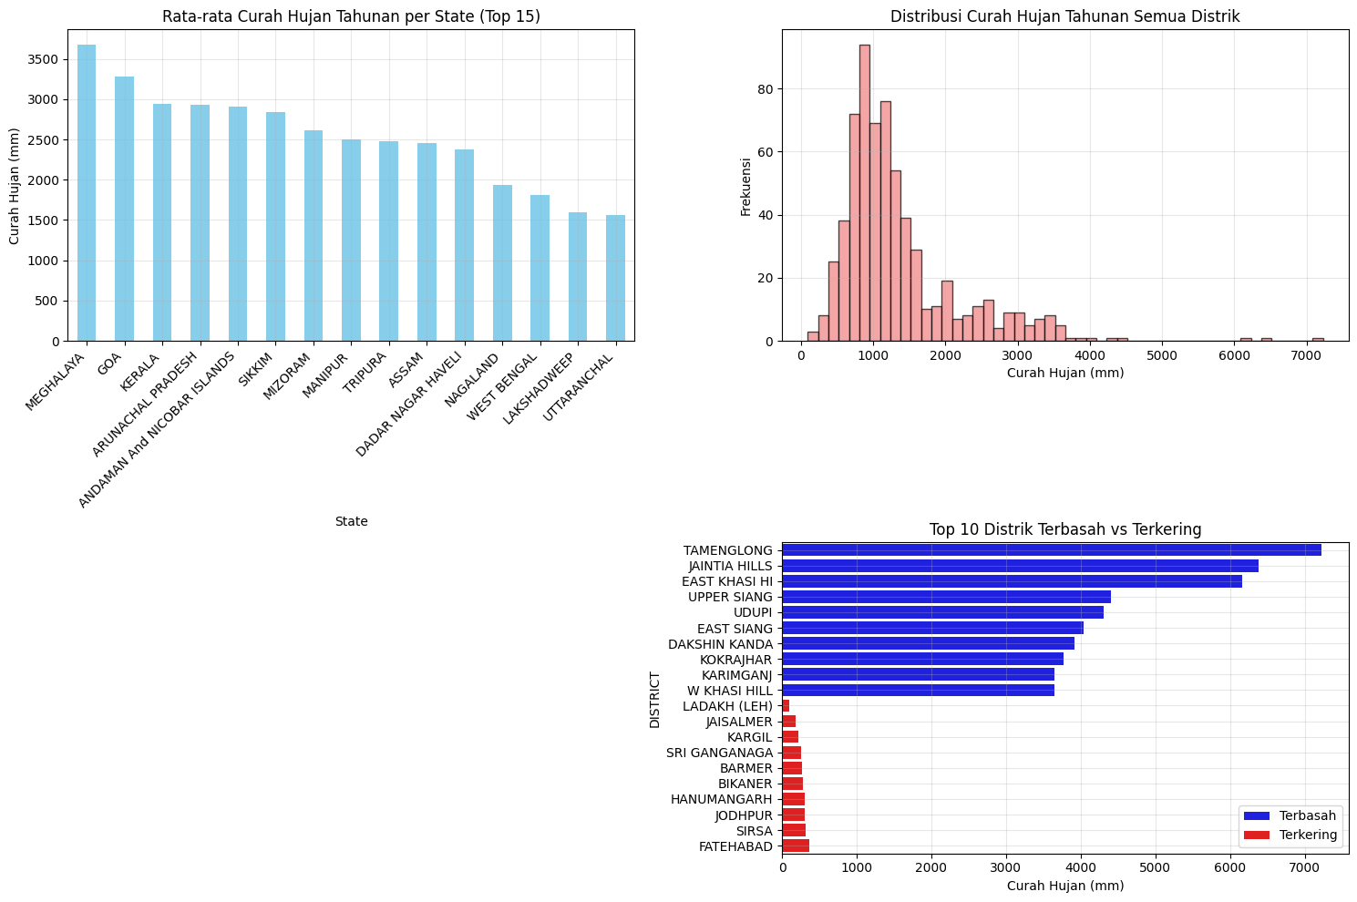

Grafik 9: Pola Musiman
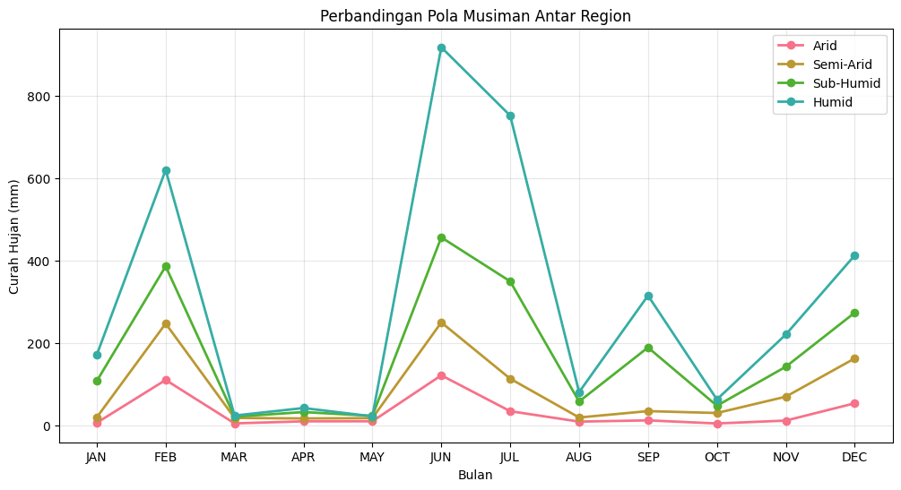
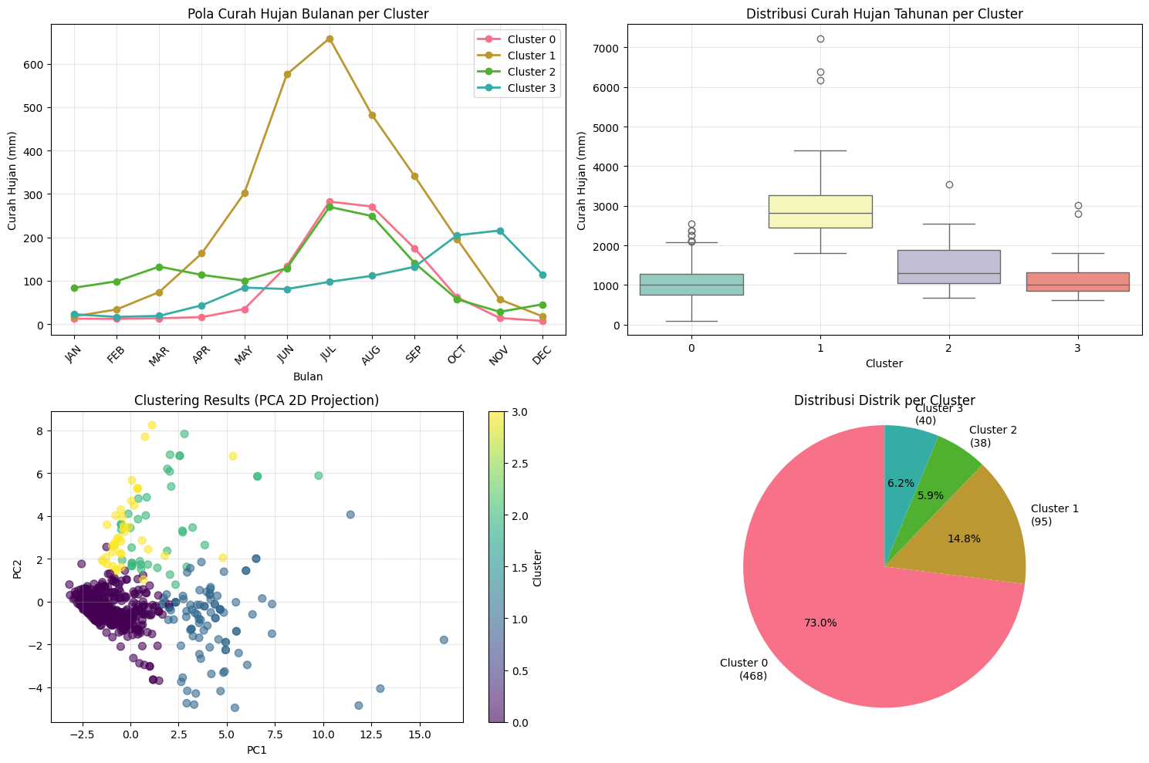

6.2 Geographic Visualization
Grafik 10: Heatmap Curah Hujan per State
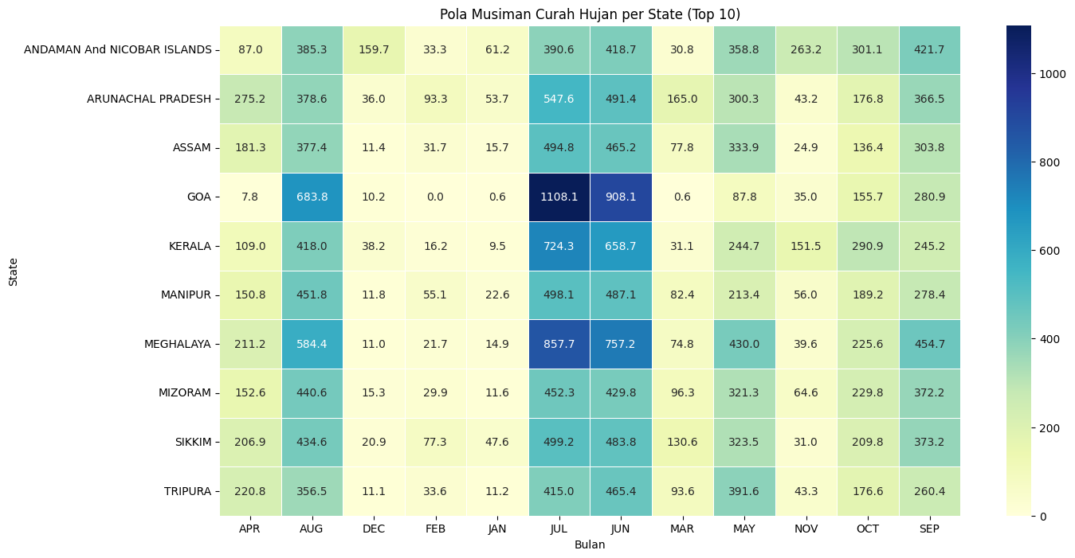

7. ANALISIS LANJUTAN

7.1 Klasifikasi (3 Kategori)
Screenshot 7: Classification Report
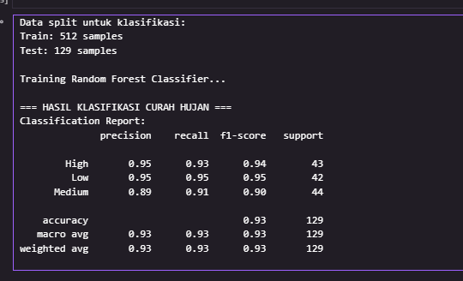
Grafik 11: Confusion Matrix
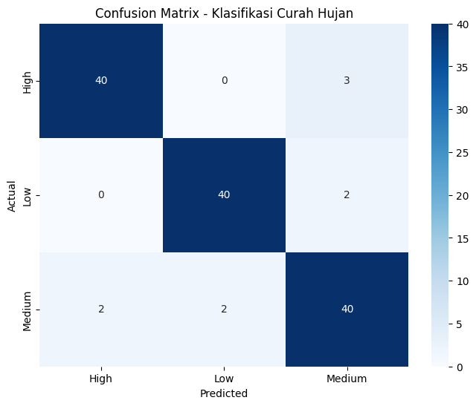

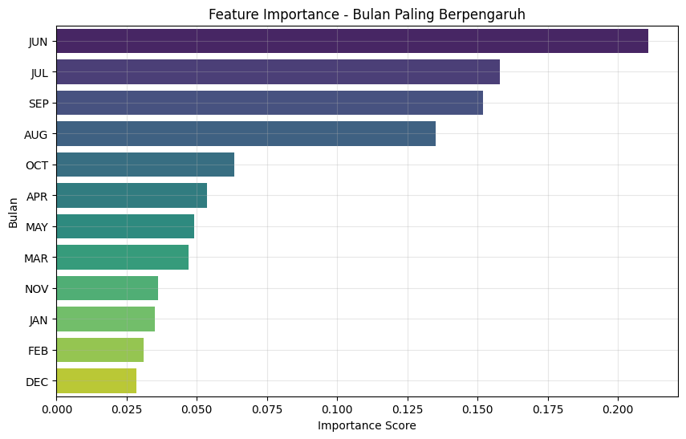

7.2 Clustering Analysis
Grafik 12: K-Means Clustering (PCA 2D)
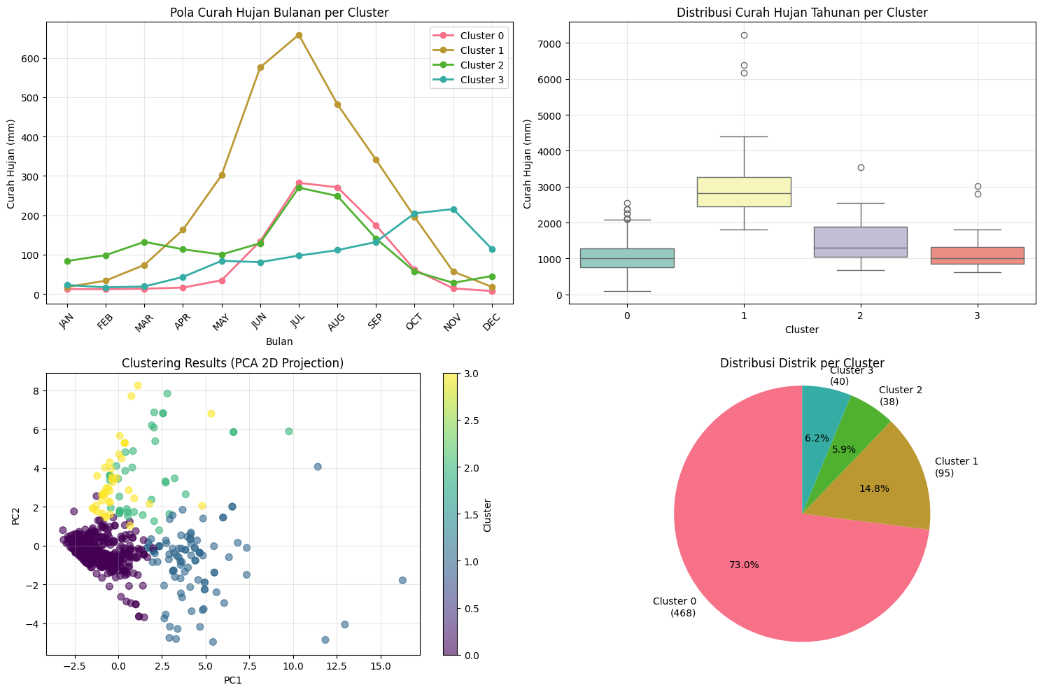

7.3 Perluasan Domain Analisis
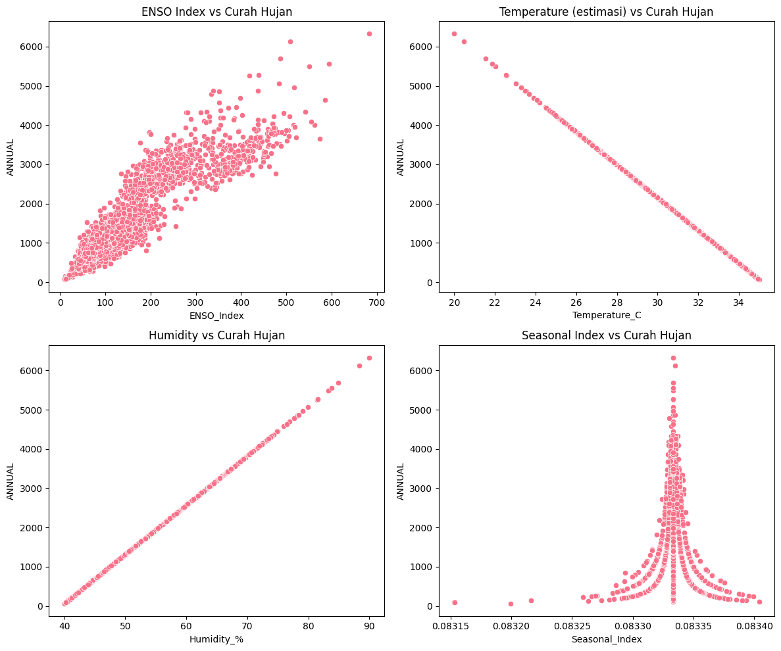
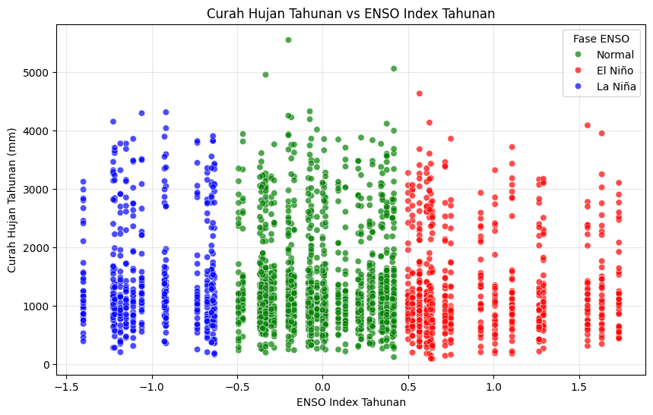
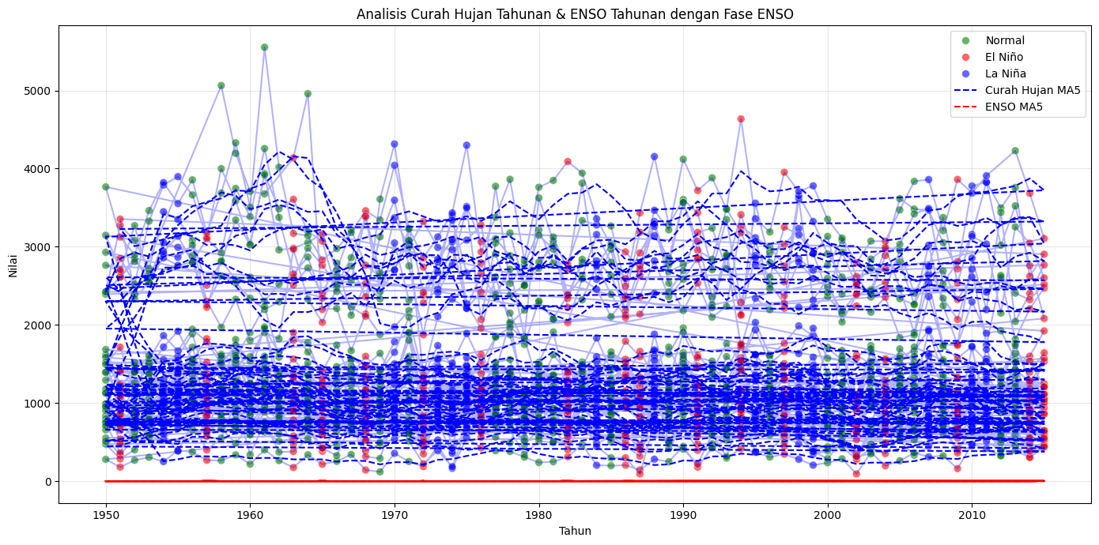

7.4 Anomaly Detection
Grafik 13: Boxplot Deteksi Anomali
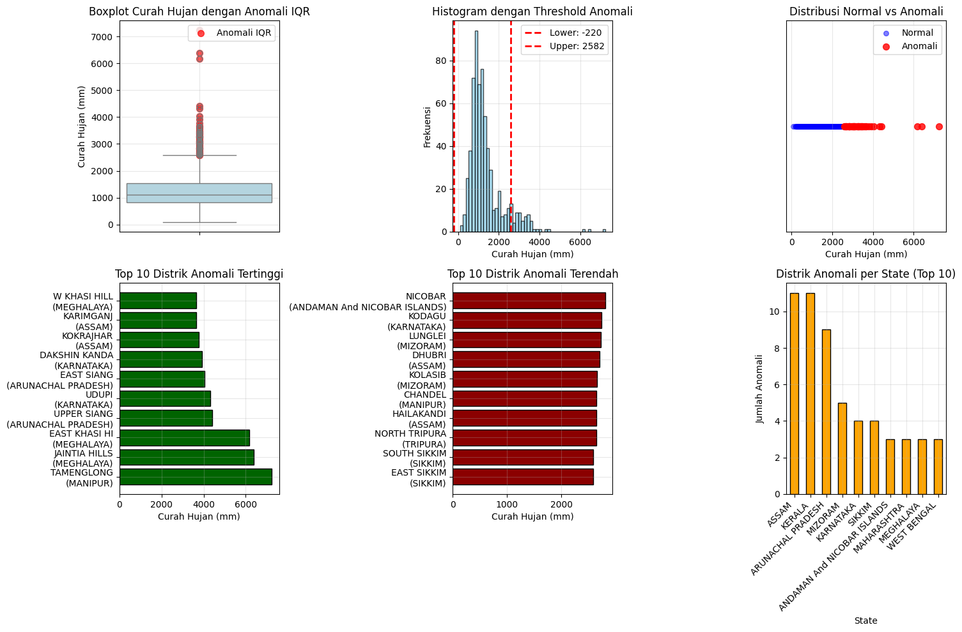

8. MAPPING MODELS (PERBANDINGAN GEOGRAFIS)

8.1 Peta India - Data Real vs Prediksi
Screenshot 8: Dual Choropleth Maps
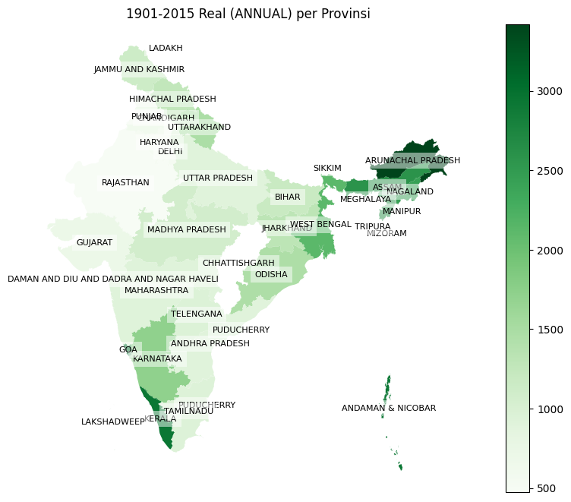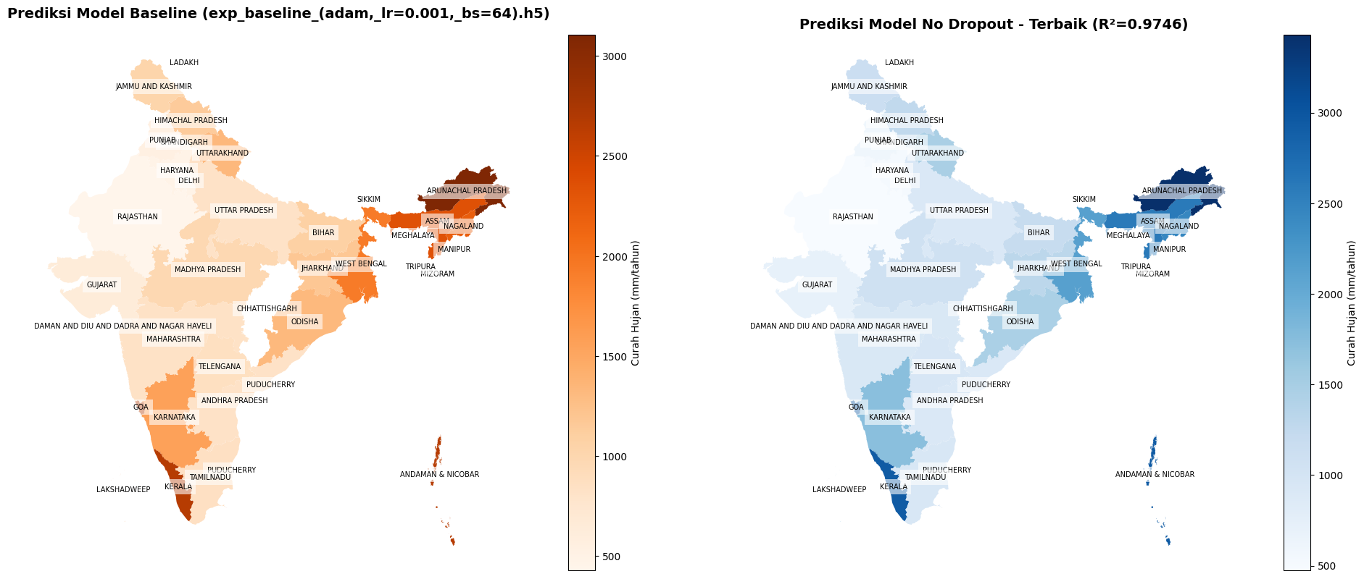

8.2 Performa Geografis (R² Score)
Grafik 14: Distribusi R² per Subdivisi
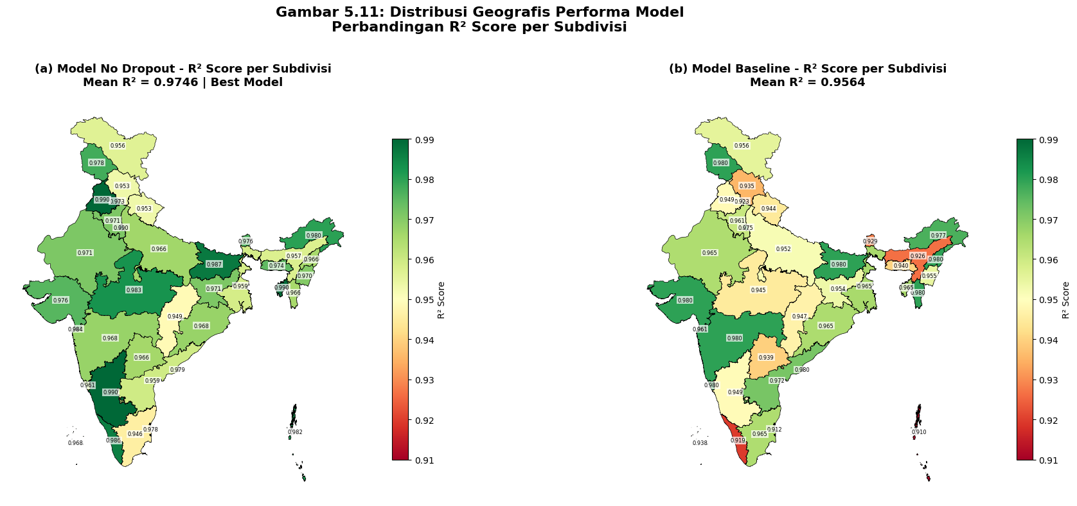

9. POTONGAN KODE PENTING

9.1 Data Preprocessing
Code Snippet 1: Monthly to Daily Transformation
python

def monthly_to_daily(df):
daily_data = []
for year in df['YEAR'].unique():
year_data = df[df['YEAR'] == year]
for month in ['JAN','FEB','MAR','APR','MAY','JUN',
'JUL','AUG','SEP','OCT','NOV','DEC']:
rainfall = year_data[month].values[0]
days_in_month = calendar.monthrange(year, month_num)[1]
daily_rainfall = rainfall / days_in_month
for day in range(days_in_month):
daily_data.append(daily_rainfall)
return np.array(daily_data)

9.2 Sequence Creation
Code Snippet 2: Create LSTM Sequences
python

def create_sequences(data, seq_len=30):
X, y = [], []
scaler = MinMaxScaler()
scaled_data = scaler.fit_transform(data.reshape(-1,1))

for i in range(len(scaled_data) - seq_len):
X.append(scaled_data[i:i+seq_len])
y.append(scaled_data[i+seq_len])

return np.array(X), np.array(y), scaler

9.3 Model Building
Code Snippet 3: LSTM Architecture
python

model = Sequential([
LSTM(64, return_sequences=True, input_shape=(30, 1)),
Dropout(0.2),
LSTM(32, return_sequences=False),
Dropout(0.2),
Dense(16, activation='relu'),
Dense(1)
])

model.compile(optimizer='adam', loss='mean_squared_error')

9.4 Training Loop
Code Snippet 4: Model Training
python

history = model.fit(
X_train, y_train,
validation_data=(X_test, y_test),
epochs=100,
batch_size=32,
callbacks=[
EarlyStopping(monitor='val_loss', patience=10,
restore_best_weights=True),
ModelCheckpoint('best_model.h5', save_best_only=True)
],
verbose=1
)

9.5 Evaluation
Code Snippet 5: Calculate Metrics
python

# Predictions
predictions = model.predict(X_test)
predictions_inv = scaler.inverse_transform(predictions)
y_test_inv = scaler.inverse_transform(y_test)

# Metrics
mse = mean_squared_error(y_test_inv, predictions_inv)
rmse = np.sqrt(mse)
mae = mean_absolute_error(y_test_inv, predictions_inv)
r2 = r2_score(y_test_inv, predictions_inv)

print(f"RMSE: {rmse:.4f} mm")
print(f"MAE: {mae:.4f} mm")
print(f"R²: {r2:.4f}")

